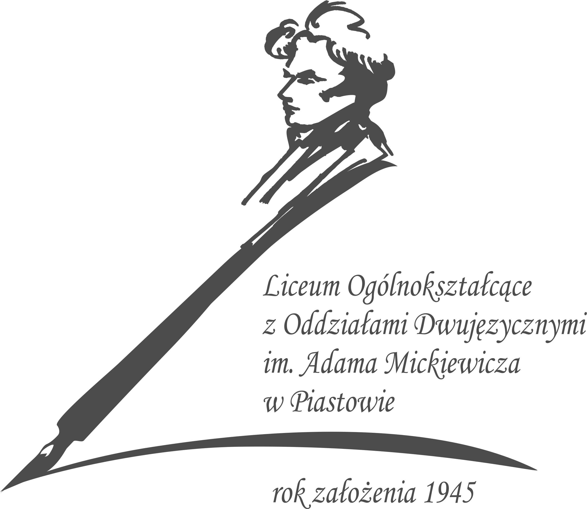

LANGUAGE POLICY
LICEUM OGÓLNOKSZTAŁCĄCE Z ODDZIAŁAMI DWUJĘZYCZNYMI
IM. ADAMA MICKIEWICZA

INTRODUCTION

This policy has been written for the purpose of the IB Diploma Programme that our school is aiming to implement in the nearest future (school year 2022/2023) and is an attempt to create a fundamental school language policy meant as a linguistic instruction at Liceum Ogolnokształcące z Oddziałami Dwujęzycznymi im.Adama Mickiewicza. The document was created in cooperation with language teachers in our school, including teachers of our national, Polish language, and in cooperation with other members of the school community: the librarian, vice-head being a part of the steering committee, and as an outcome of a consultation process with all interested parties. The following have been explained in the policy: the philosophy of the process of language learning/teaching, the aims of the language education in our school, a description of the language and literature and foreign language acquisition being distinctive offer of our school.

Liceum Ogolnoksztalcace z Oddzialami Dwujezycznymi im.Adama Mickiewicza presents its evolving development towards teaching bilingualism and teaching/learning foreign languages (both native and foreign) that over the years has become one of the prime priorities of education in our school. Promoting languages materializes by participation in exchange projects with schools abroad (Germany, Latvia) and involvement in international cooperation during completion of plentiful Erasmus projects.

The teachers fully recognize the importance of possessing a proficient command of English as the language of instruction and one of the communication languages while implementing the IB system. All teachers understand that learning and teaching a language is the basis for communication and thus a constant way of making progress in the field of education. To foster learning languages all teachers encourage and attempt to boost their students’ speaking skills at school. Languages being a part of entry requirements (Admissions Policy) play an important role at our school.

In order to cater for students’ linguistic needs, all teachers must recognise the importance of an on-going linguistic professional development as the language of instruction is not students’ and teachers’ native language. The school provides students with an on-going support if they struggle with the language of instruction by means of aditional classes and consultations with their language teachers.

PHILOSOPHY

Language stands at the center of the many interdependent cognitive, affective,
and social factors that shape learning.
Corson (1999)

Language is crucial to learning, to the construction of knowledge and to cognitive growth. That is why all teachers are understood as language teachers and have a responsibility to facilitate the communication. The basic goal of language teaching and learning is the ability to communicate effectively in a language, both orally and in the writtten form. Concurrently, at our heart’s desire is the need to develop students' sense of responsibility, love for the homeland and respect for the Polish cultural heritage, education in the spirit of tolerance, international mindedness, humanism and patriotism, sharing knowledge about society, social and economic problems of the country and the world, culture and natural environment.

Mother tongue

With the exception of a few individual cases, the basic language of communication used in Liceum Ogolnoksztalcace z Oddzialami Dwujezycznymi im.Adama Mickiewicza and outside the classroom is Polish. The school guarantees equal access to the IB DP programme for learners who are learning in a language other than their mother tongue.

The School Library

The School Library is an integral part of language teaching/learning, being an interdisciplinary school laboratory, serving the students’ needs and interests, school's educational tasks, improving teachers' work skills, and popularizing pedagogical knowledge among parents. The Online Multimedia Center in the School Library is a place for students to work independently, or in groups, under the supervision of a teacher. The school library:
- amasses, in cooperation with teachers, a selected collection of books and materials necessary for the implementation of IB teaching programmes;
- enables the school community to use its collections;
- organizes additional educational workshops and events for students, teachers and parents.

LANGUAGE POLICY AIMS

1) equipping students with high competences of mastering their mother tongue and modern foreign languages;
2) enriching the knowledge about the culture, history and everyday life in other countries;
3) shaping broad understanding of universal attitudes;
4) acquiring competences of effective communication in various situations and presenting student’s own point of view and taking into account the views of other people,
5) promoting the correct use of the mother tongue,
6) preparing students to speak in public and to debate in the public fora,
7) teaching effective team cooperation and building interpersonal bonds,
8) promoting a class/school environment that welcomes and embraces the diversity of cultures and
perspectives

To foster:

- knowledge, the scope of which is determined by the curricula implemented by the teachers (knowledge of compulsory reading set-books, concepts and definitions from the history and theory of literature and the science of language);
- skills, which are specified in detail in the educational documents: programmes curricula that are listed in the educational requirements for each class;
- attitudes: the level of student's involvement in the education process (active and involved participation in lessons, reporting and answering, listening and taking notes actively, executing instructions and participating in the team work, doing homework systematically, readiness to perform additional tasks, participation in subject and subject-related competitions, etc.)

LANGUAGE OFFER AT LICEUM OGLÓLNOKSZTĄŁCĄCE Z ODDZIAŁAMI DWUJĘZYCZNYMI IM. ADAMA MICKIEWICZA

1. LANGUAGE AND LITERATURE: POLISH

Students are presented with a selection of two levels of Language: the Standard Level or the Higher Level. In the event of non-native speakers of Polish at school, Liceum Ogolnokształcące z Oddziałami Dwujęzycznymi im.Adama Mickiewicza in Piastów effectuates support to such students exclusively to facilitate a proficient acquisition of Polish. Similarly, such students, if their native language is different from the languages offered by our school, will be supported in their self-taught development and maintenance of their mother tongue.

Responsibilities of the School, students and parents

Students whose first language is not Polish are given an opportunity to select their Language A mother tongue as the subject from Group 1 offered in the International Baccalaureate.
The responsibility for finding a qualified IB language tutor rests with the students’ parents, who are accountable for informing the school about their choice of the teacher. Payment of any additional tuition fees is at the discretion of the parents.

Students follow the language program other than Polish outside the school (beyond teaching schedule).At the same time, they are obliged to meet all the requirements described in the school Assessment Policy. All Internal Assessments, projects, and exams being a part required by the IB Programme in their school must be passed / submitted at school in a formal manner.

The programme other than Language A Polish is carried out individually by students after agreeing the conditions for passing the course with the IB DP school coordinator and submitting relevant statements by the student’s parents to the school secretary's office.

2. LANGUAGE ACQUISITION

The school ensures the development of a language continuum scope by providing students with means and ways to thrive and grow their language profile among other things by creating opportunities for learning Language Ab initio and group B languages.

LANGUAGE B : ENGLISH

With English being the language of instruction for all lessons (with the exception of Polish - Language A and foreign languages), all the offered subjects will be entirely conducted in English. The school offers the Higher Level of English. We do not expect students to follow the Standard Level, nevertheless, we might reconsider our Programme Offer and to widen Language B selection if the needs arises. The school expects that commencing education in our school, IB DP students represent the command of proficiency of English at the B2 level in the Common European Framework of Reference for Languages and that is why students are expected to choose the Higher Level.
The main objective of the English course is to develop students’ linguistic potential and not only
prepare them for the final exam in Language B, but allow them to master the language as an important tool to acquire knowledge and skills in all the subjects of the curriculum.

LANGUAGE B: FRENCH

The school offers the Standard Level of French. We expect that at the start of their education in our school, IB DP students represent the command of proficiency of French at the B1 level in the Common European Framework of Reference for Languages and that is why students are expected to choose the Standard Level. In the case of students whose command of French is not sufficient enough to start their IB DP education at the Standard or exceeds the expectations to reach the Higher Level, the school will consider the extension of the educational offer and offer the ab initio option and/or Higher Level for this language.

LANGUAGE B: Ab initio GERMAN

IB DP students are given an opportunity to choose Ab initio German Language in Liceum Ogólnokształcące z Oddziałami Dwujęzycznymi im.Adama Mickiewicza in Piastów. In the case of students whose command of German is sufficient enough to start their IB DP education at the Standard or Higher Level, the school will consider the extension of the educational offer.

The main objective of the Ab initio language learning/teaching is to give students a chance to learn
another foreign language different from English.

All foreign language teachers in Liceum Ogólnokształcące z Oddziałami Dwujęzycznymi im.Adama Mickiewicza in Piastów aim to develop their students’ interactive, receptive and productive skills and in the case of students choosing the Higher Level, familiarise them with selected literary texts in the target language. The teachers will make an effort to provide their students with a balanced and integrated reinforcement of students’ speaking, listening, writing and reading abilities and develop their curiosity of the world and international mindedness. The IB DP language teachers are determined to put great emphasis on communication skills of their students and allowing them to function successfully on the educational and professional markets in the future.

REVIEW AND EVALUATION

This is a working document that will be revised by the school on annual basis according to the IB guidelines, basing on the experiences on the schools path to implement the IB DP programme.The school initiates and develops the system of maintaining the language profile of each student by keeping track of the student's progress in the implementation of Language A-Polish and selected subjects from the Language B group. Teachers are going to record information in learner profiles that will support planning for future differentiation. The school is planning to monitor the effectiveness of differentiating strategies for students with special needs towards language / foreign language learning. This document is in line with the Admission, the Assessment , SEN and Academic Integrity Policies.

BIBLIOGRAPHY/REFERENCES:

Guidelines to developing a language policy, IB 2008
Learning in a language other than mother tongue in IB programmes
IB DP school: LO im.Wl.Jagielly, Language Policy, Plock

