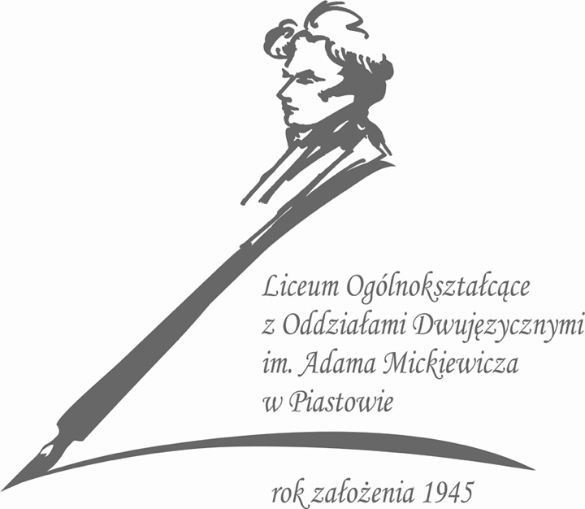

ACADEMIC HONESTY and INTEGRITY POLICY
‘You have to study for a long time not to get lost
And everyone should be honest’.
Adam Mickiewicz, ‘Master Thaddeus’, Poland’s national epic

High standards of integrity constitute the unique reputation of IB schools. They are the basis of mutual trust and a source of development for students who will become conscious and responsible citizens in the future. Therefore, a culture of respect for oneself and others must be especially nurtured and developed. In line with these standards, we have prepared a document describing the basic principles of academic honesty in the IB grades, in Liceum Ogólnokształcące z Oddziałami Dwujęzycznymi imienia Adama Mickiewicza - Adam Mickiewicz Secondary School with Bilingual Classes in Piastów.
The purpose of the document is to present the rules that apply to the entire school community, both students and teachers. These principles define what is reliable scientific work based on respect for intellectual property as well as the efforts of others. The document promotes academic integrity and indicates the consequences if such integrity is not maintained.
Academic honesty is a core value at every stage of education, whether we consider individual and group work, all forms of assessment or preparation of scientific papers. Therefore, all members of the school community should always indicate the sources used, recognize the work and ideas of others, use information technology and social media responsibly, and apply fair practices during exams.
It should be remembered that intellectual property defined as a unique product of human creative work deserves special protection due to its high cultural or economic significance. Thanks to the rules in force, students at our school are aware that everything that a person creates using intellect, everything which is unique and innovative, is intellectual property and is subject to protection.
Documents posted on www.ibo.org, which are a benchmark for standards of performance for our school community, indicate that:
Academic integrity - is a guiding principle in education and a choice to act in a responsible way whereby others can have trust in us as individuals. It is the foundation for ethical decision-making and behaviour in the production of legitimate, authentic and honest scholarly work (Academic Integrity, published October 2019).
Academic honesty - “must be seen as a set of values and skills that promote personal integrity and good practice in teaching, learning and assessment. It is influenced and shaped by a variety of factors, including peer pressure, culture. Parental expectations, role modelling and taught skills”. (IBO Academic Honesty Policy, 2007).
“The concept of intellectual property is potentially a difficult one for candidates to understand because there are many different forms of intellectual property rights, such as patents, registered designs, trademarks, moral rights and copyrights. Candidates must at least be aware that forms of intellectual and creative expressions (for example, works of literature, art or music) must be respected and are normally protected by national and international law.” (IBO Academic Honesty Policy, 2007)
“An authentic piece of work is one that is based on the candidate’s individual and original ideas with the ideas and work of others fully acknowledged. Therefore, all assignments. Written or oral, completed by a candidate for assessment must wholly and authentically use that candidate’s own language and expressions. Where sources are used or referred to, whether in the form of direct quotation or paraphrase, such sources must be fully and appropriately acknowledged.” (IBO Academic Honesty Policy, 2007).
Students must acknowledge use of the following:
- the work and ideas of other,
- versions of another person’s words,
- CD-roms, e-mail messages, websites, chat rooms, blogs,
- electronic media (YouTube, Podcasts, news feeds, etc.)
- sources of photographs, maps, illustrations, computer programmes, data, graphs, audiovisuals,
- direct quotations, works of art, including film, dance, music, theatre arts, visual arts. (IBO Academic Honesty Policy, 2007).
Regardless of whether breaking established rules is intentional or accidental, the damage caused by it is far-reaching. It poses a real threat to the proper conduct of teaching and learning: students do not achieve desired results and there may be a feeling of dissatisfaction with the final results as well as uncertainty if the school promotes and accepts academic integrity. Consequently, the school's reputation may suffer, and ultimately the validity of grades or qualifications awarded to students may be affected.
Therefore, we emphasize that our school makes every effort to promote academic integrity and this document is a premise that all members of the school community support the principles described in this paper.

Proper conduct during examination session, writing assignments and testing procedures
Students understand what the academic honesty policy is. During IB DP programme they discover what is justice and respect. They have to review their work before submitting e.g. check if all citations or quotations have sources. Students understand what are: plagiarism, collusion, duplication, too much assistance.
Academic honesty is emphasised since the very first moment a student comes to our school (be that bilingual preparatory or IB Year 1 class). In IB Year 1 class students have to read and sign Adam Mickiewicz Secondary School Academic Honesty Policy as a confirmation of understanding and accepting its requirements.
The documentation will be kept at the IB coordinator’s office. A separate computer will be the carrier for the digital data while the documentation in the paper form will be stored in a special locker. Backup files will be stored on an external drive in the coordinator's office.

Malpractice
The International Baccalaureate Organization defines malpractice as “behavior that results in, or may result in, the candidate or any other candidate gaining an unfair advantage in one or more assessment components.” (IBO Academic Honesty Policy, 2007).
Malpractice can include:
- Plagiarism (according to a new plagiarism definition) – is defined as the representation, intentionally or unwittingly, of the ideas, words or work of another person without proper, clear and explicit acknowledgment.
- Collusion - supporting malpractice of another candidate, as in allowing one’s work to be copied or submitted for assessment by another candidate.
- Duplication - presenting the same work for different assessment components and/or diploma requirements.
- Too much assistance.
- Taking unauthorized material into an examination room.
- Stealing examination materials.
- Disruptive behavior during examination.
- Discussing examination papers within 24 hours after a written examination.

Responsibilities of school staff members
The IB Coordinator and teachers are obligated to impose the policy of academic honesty, e.g.:
• t0 promote integrity and independence of students’ work,
• make students aware of the benefits of writing work independently and indicate the consequences of not following the principles of independent work,
• to indicate good and bad practices,
• not to open the examination papers earlier and conduct the exam sessions at the time set by the IB, taking into account the time zones,
• not to leave students unattended during the exam sessions,
• make sure that students do not take any materials from the examination room,
• to remind students not to discuss the examination tasks for 24 hours after the exam,
• check the work of students in the www.plagiat.pl system.

Avoiding malpractice
- Plagiarism
Plagiarism is a very broad concept, usually defined as a representation of the ideas or work of another person as the student's own. Since the Internet is a public domain, easily accessible to every student, students and teachers must keep in mind the following:
- any information that appears in students’ work must be credited by a credible source by creating a footnote,
- copying someone’s work from another language and translating it into student’s own language must be avoided,
- all graphics, illustrations, charts, photos must also have sources,
- paraphrasing words or changing a few words in part of the work without specifying the source is also a violation of the principles of academic honesty.
- Collusion and duplication
Students must remember to create works on their own. Even if they work in groups, they must present their own position. Moreover, they cannot use other students’ works (be inspired by their content or claim ownership entirely).
- Too much assistance
Students must remember that creating works with a large participation of the tutor and his or her possible instructions is also a violation of the principles of academic honesty.
- Cite and acknowledge sources
The school has developed standards and unified methods of creating footnotes, citing rules and creating a bibliography following the MLA standards (Modern Language Association). Each teacher introduces this system in the first lessons of their subject.

Responsibilities of the IB Coordinator and school administration
In order to create an environment that sets an example and encourages fair conduct in the scientific process, the school administration and the IB Coordinator:
- inform the community of both students and staff what is the right practice and what is not approved,
-cooperating with IB, they undertake activities aimed at checking and drawing consequences against people who do not respect the policy of academic integrity.

Teacher Responsibilities
Teachers provide students with the idea of an academic integrity policy and IB guidelines for writing, conducting the research process and formulating conclusions.
Teachers show students tools to help detect plagiarism and inform them how to use the achievements of others in their own work and how to post quotes.
Teachers inform about the procedures and formal requirements for the assessment of individual and group works and confirm that students' works are independent and authentic when submitting them for assessment.

Student Responsibilities
It is the student's responsibility to respect the deadlines for the submission of papers, to apply the policy of academic integrity in written and oral assignments, and to learn with the help of teachers how to correctly cite and use the achievements of others in their own work.
The course of the process of checking the violation of the integrity policy
If irregularities are suspected:
- the teacher informs the IB Coordinator and the School Head,
- the teacher and the IB Coordinator check whether the integrity policy has been breached,
- the teacher or the IB Coordinator informs the parents of the student about the event, and in case of confirmation of irregularities the teacher or IB Coordinator informs the student and his/her parents about the consequences.

Parents’ responsibilities
Parents are supposed to:
- Read the Academic Honesty Policy and be aware of its expectations and consequences.
- Understand what constitutes academic honesty.
- Support students in taking responsibility for their actions.
- Recognize that the goal of school is to develop student’s knowledge, and promote inquiry.
- Help students choose balanced work load.
- Promote and model integrity and core ethical values.
- Encourage son or daughter to adhere to the Policy while working at home.
- Help son or daughter manage his or her schedule with academics and extra-curricular activities.
- Support the consequences, if the Academic Honesty Policy has been violated.
- Encourage and help students advocate for themselves (ask for help when needed, attend tutorial, ask questions to improve understanding/learning).

Consequences of breaking the integrity policy
Students are responsible for the authenticity of their papers and must be aware that the papers will not be submitted to the IB if they violate the principles of academic integrity or if there is such a suspicion.
If any irregularities are found, the student has an option to prepare another work, if the delivery deadline has not expired. If the student does not prepare another work, they will receive a Fail mark.
If any irregularities are found after the delivery deadline or during the checking students’ works by the IB examiners, the student will not receive the IB diploma.

Assessment appeals procedures
As indicated in the document Diploma Programme: Assessment appeals procedure for use from September 2016: Appeals are possible against:
a. results—when a school has reason to believe that a candidate's result(s) are inaccurate after all appropriate enquiry upon results procedures have been completed
b. a decision upholding academic misconduct, but not the penalties imposed for misconduct
c. a decision in respect of special consideration—following a decision not to give special consideration to a candidate as a consequence of alleged adverse circumstances
d. a decision in respect of inclusive assessment arrangements after all appropriate procedures have been completed
e. an administrative decision not covered by one or more of the foregoing circumstances that affects the results of one or more candidates.

The appeals process is divided into two stages. Each stage will usually require the payment of a fee. The fee will be refunded if the decision being appealed changes.
Detailed information can be found in the above document

Document evaluation
The rules and guidelines of conduct do not cover all situations that may take place in the process of upbringing and teaching. The issues contained in the document will be subject to evaluation and possible correction in the future.

FAQs
What is Academic Integrity?
Academic integrity is a guiding principle in education and a choice to act in a responsible way whereby others can have trust in us as individuals. It is the foundation for ethical decision-making and behaviour in the production of legitimate, authentic and honest scholarly work
(Academic Integrity IBO 2019)
What is Intellectual Property?
Intellectual Property refers to creations of the mind therefore it refers to all kinds of inventions, patents, designs, artistic and literary works, logos, trademarks, symbols etc.
What is plagiarism?
Plagiarism means using by a student exact words, ideas, data or other sources which are intellectual property of another person and the source has not been cited.
What is paraphrasing?
While writing an essay paraphrasing means expressing your own thoughts using another person’s thoughts, ideas or concepts. Words that should not and cannot be changed are e.g. the names of places, people, substances etc. Other concepts are supposed to be expressed in your own words.
What is cheating?
Cheating means using cribs or any other aids or tools during assessment. Plagiarism, using unauthorized materials, collusion are also forms of cheating.
What is collusion?
Collusion means more than one student working on an individual assignment (students’ ‘cooperation’ without teacher’s permission). It also means copying another’s student work.
What is Bibliography?
Bibliography is a list of references put in the alphabetical order (by the authors) whose works have been cited. This list should be placed at the end of a work.

Bibliography
Academic honesty in the IB educational context, 2014 (www.ibo.org)
Academic Honesty Policy, 2021 (www.lwj.edu.pl)
https://www.ibo.org/contentassets/71f2f66b529f48a8a61223070887373a/academic-honesty.-principles-into-practice---celina-garza.pdf
IBO Academic Honesty Policy, 2007
IB Academic Integrity
https://www.ibo.org/contentassets/76d2b6d4731f44ff800d0d06d371a892/academic-integrity-policy-english.pdf
Diploma Programme: Assessment appeals procedure For use from September 2016

